Multiple-choice section

|  |  |  |  |  |  |  |  |  |  |  |  |  |
| --- | --- | --- | --- | --- | --- | --- | --- | --- | --- | --- | --- | --- |
| Question | 1 | 2 | 3 | 4 | 5 | 6 | 7 | 8 | 9 | 10 | 11 | 12 |
| Answer | A | D | C | C | B | C | C | C | D | D | B | D |

Question 1 [6.1]

A

Measuring jug and mixing bowl – both points lie to the right of the cup and are higher than the saucepan.

Question 2 [6.1]

D

Total length of resting time 20 mm, total length of time axis 52 mm.

Fraction is  which is closest to four-tenths of journey time.

Question 3 [6.2]

C

(-1, -1)

2*y* + 1 = 2 × (-1) + 1

= -2 + 1

= -1

Question 4 [6.2]

C

Each column in each table forms an ordered pair (coordinate).

Question 5 [6.2]

B

Where *x* = 1, *y* = 2 × 1.5 – 3 = 0. The point is (, 0).

Question 6 [6.2]

C

(1.5, 0) and (0,-3)

Question 7 [6.3]

C

*y* = 3*x* + 2 is true for all pairs of values.

Question 8 [6.2]

C

For :where *x* = 3, *y* = 1 – 3 × 3 = 1 – 9 = -8,

so the point (3, -8) is on the line.

For *x* = *y* + 11:

where *x* = 3, 3 = *y* + 11

3 – 11 = *y*

*y* = -8

so the point (3, -8) is on the line.

Question 9 [6.2]

D

For the line: , *y* = 0:





Question 10 [6.2]

D

The line with equation  crosses the *y*-axis at *y* =.

Question 11 [6.2]

B

The line with equation  has a gradient of 0.01, which means that the line is nearly flat.

Question 12 [6.4]

D

For where *C* = 119:



*d* = 23

Frank rented the car for 23 days.

Multiple-choice total marks: 12

Short answer section

Question 13 7 marks [6.2]

(a) Lines with a *positive* gradient *slope* up to the right and lines with a *negative* gradient *slope* up to the *left*.

(b) The *gradient* of a line is a measure of its steepness.

(c) The *x*-intercept is where a line crosses the *x-axis* and the *y-intercept* is where a line crosses the *y*-axis.

(d) The point (0, 0) is the *origin* of the *Cartesian* plane.

(e) When points on a graph make a *straight line* then the relationship between the variables is *linear*.

(f) When lines are flat they have a gradient of *zero*.

(g) In the equation ,  is the *gradient* of the line and  is the *y-intercept* of the line.

Question 14 3 marks [6.2]

Answers will vary.

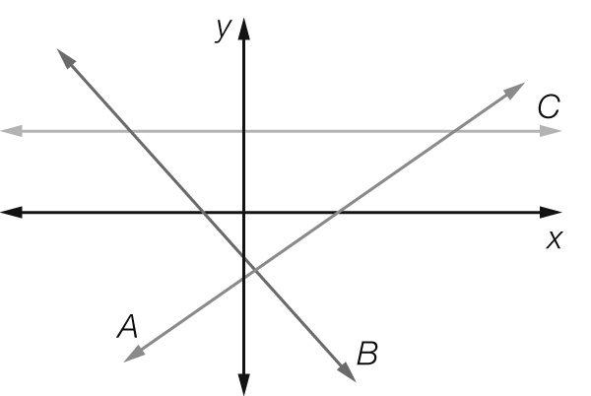

As line *A* slopes up to the right, it has a positive gradient.

As line *B* slopes up to the left, it has a negative gradient.

As line *C* is flat, it has a zero gradient.

Question 15 2 marks [6.2]



Question 16 4 marks [6.1]

(a) Height and weight (the axis labels)

(b) About  times

(c) About twice

(d) Sharon is tallest followed by Xanthia. Alex is the shortest. Xanthia is the heaviest followed by Alex. Sharon is the lightest person in the group.

Question 17 3 marks [6.1]

(a) *A*: steeper lines represent faster speeds.

(b) *B*: horizontal lines represent no movement.

(c) Approximately one-and-a-half times faster.

Question 18 3 marks [6.2]

|  |  |  |  |  |  |  |  |
| --- | --- | --- | --- | --- | --- | --- | --- |
| *x* | -3 | -2 | -1 | 0 | 1 | 2 | 3 |
| *y* | 0.5 | 1 | 1.5 | 2 | 2.5 | 3 | 3.5 |

Question 19 4 marks [6.3]

|  |  |  |  |  |  |  |  |
| --- | --- | --- | --- | --- | --- | --- | --- |
| *x* | -3 | -2 | -1 | 0 | 1 | 2 | 3 |
| *y* | 7 | 5 | 3 | 1 | -1 | -3 | -5 |

So *y* = -2*x*+1

Question 20 6 marks [6.3]

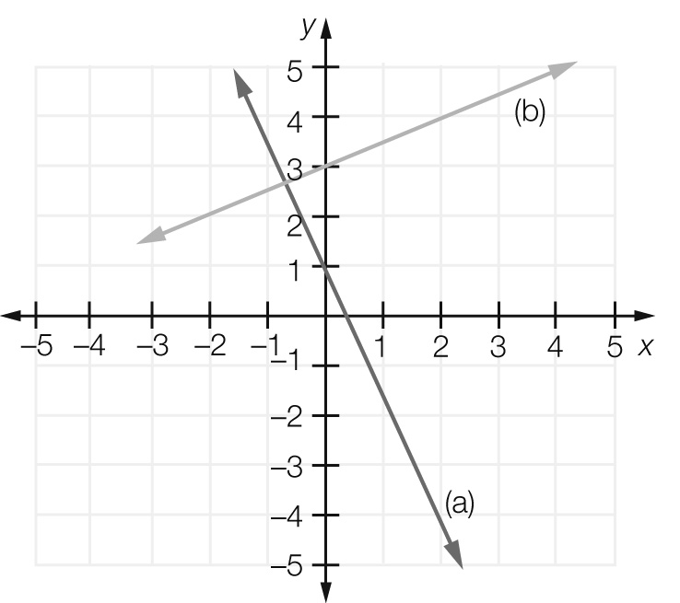

(a) *m* = , *c* = 1, 

(b) *m* = , *c* = 4, 

Question 21 4 marks [6.3]

(a) *y* = or 

(b) *y* =  or 

Question 22 2 marks [6.2]

*x*-intercept: ; *y*-intercept: 

Question 23 3 marks [6.2]

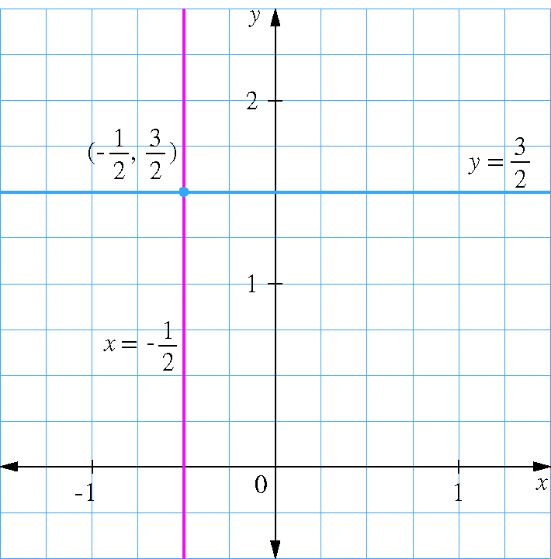

Point of intersection: 

Question 24 1 mark [6.3]

Vertical line through (,). Rule: 

Short answer total marks: 42

Extended answer section

Question 25 5 marks [6.1]

(a)

|  |  |  |  |  |  |
| --- | --- | --- | --- | --- | --- |
| Distance from start (km) | 0 | 500 | 500 | 900 | 900 |
| Petrol in tank (L) | 60 | 18 | 30 | 2 | 60 |

(b)

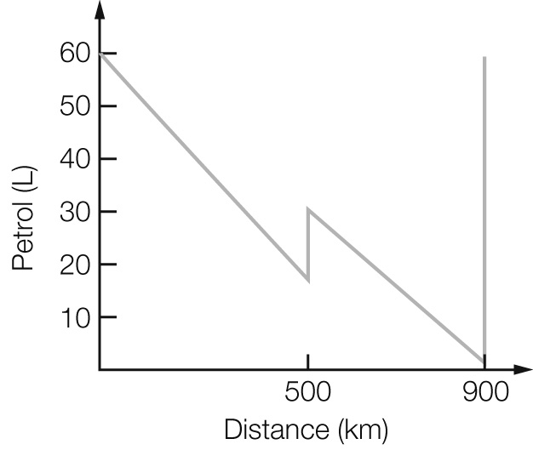

(c) The car used 42 L over 500 km (8.4 L/100 km) for the first part of the trip, and 28 L over 400 km (7 L/100 km) for the second part of the trip.

(d) The line falls more steeply for the first part.

Question 26 5 marks [6.3]

(a) 

(b)

|  |  |
| --- | --- |
| Number of triangles  (*t*) | Number of matches  (*m*) |
| 1 | 3 |
| 3 | 7 |
| 5 | 11 |
| 7 | 15 |
| 9 | 19 |

(c)

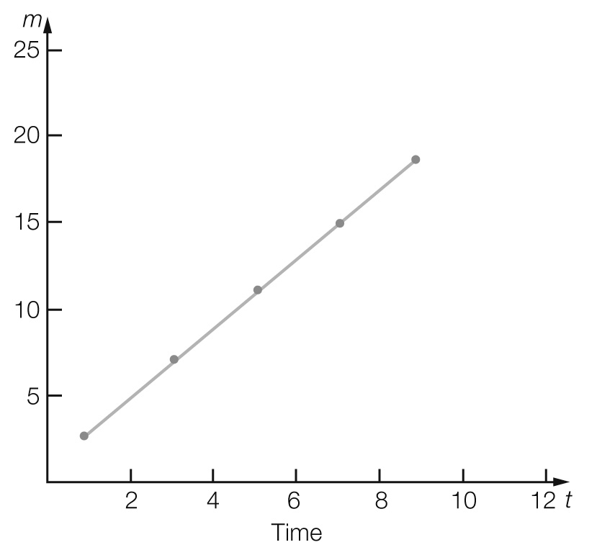

For *t* = 10, *m* = 21

Question 27 4 marks [6.3]

(a) *C* = 40 + 24.50*t*

(b)

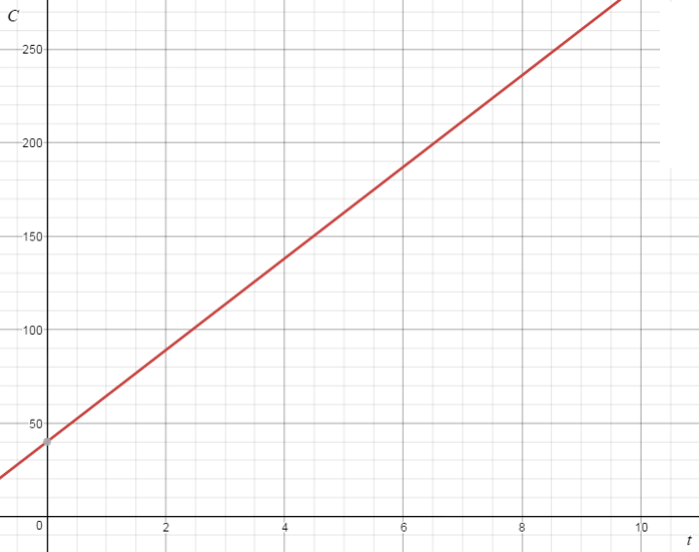

(c) $125.75

Question 28 4 marks [6.4]

(a) $3.25 + $0.80 = $4.05

(b) *T* = 3.25 + 0.8*p*

(c) *T* = 3.25 + 0.8 × 62 = $52.85

Question 29 5 marks [6.4]

(a)

|  |  |  |  |  |  |  |  |
| --- | --- | --- | --- | --- | --- | --- | --- |
| Number of feet | 0 | 100 | 200 | 300 | 400 | 500 | 10 000 |
| Number of metres | 0 | 30 | 60 | 90 | 120 | 150 | 300 |

(b) *m* = 0.3*f*, or 10*m* = 3*f*, or *m* = *f*

(c)

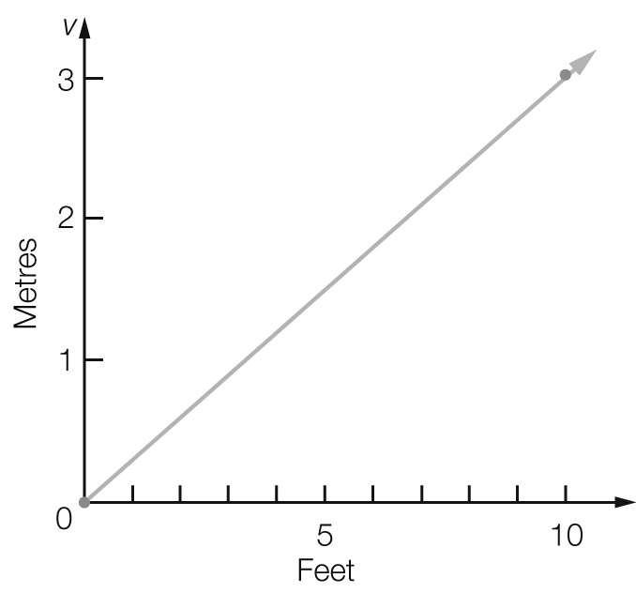

(d) Each foot is 0.3 m, and 0.3 ×  = 1.125 m or . Therefore  feet = 

(e) Each 0.3 m is 1 foot, and  ÷ 0.3 =  feet. Therefore  feet =  metres

Extended answer total marks: 23

TOTAL test marks: 77